**JAISHREE 231901011**

**EXERCISE 2 SECURITY PRINCIPLES AIM**:

To understand the Security Triad (Confidentiality, Integrity, Availability) and explore common security models and principles that help in designing and maintaining secure systems.

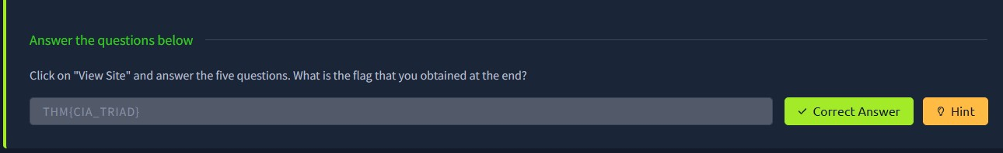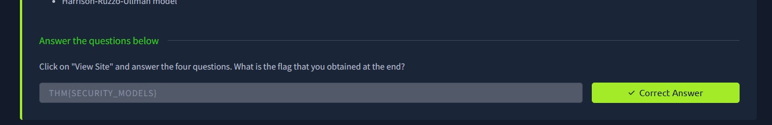

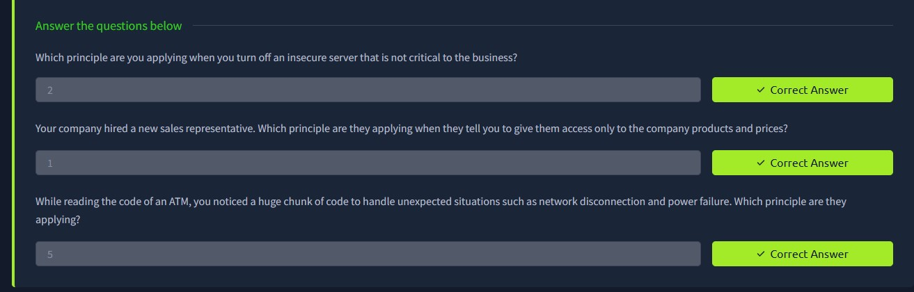

**RESULT**:

Successfully gained knowledge of the Security Triad, various security models (such as

Bell-LaPadula, Biba, and Clark-Wilson), and fundamental security principles to enhance system protection and risk management.